Product Value - Carrier/Broker Information Exchange Template

Carrier name | MPR Underwriting Limited (“MPR”)
Broker name
Product name | Management Risks Insurance for Portfolio Companies
Reference/UMR [Binder]
Reference [Class of Business] | Management Risks Insurance
Date | 01 August 2023

Carrier Information
Product information
Refer to the target market statement for this product.

Target market
Refer to the target market statement for this product.

Types of customer for whom the product would be unsuitable
Refer to the target market statement for this product.

Any notable exclusions or circumstances where the product will not respond
Refer to the policy document for this product for full details. Section 1 of the policy contains general terms. The policyholder should view the policy exclusions in their entirety for each section of cover they select.

Other information which may be relevant to distributors
The MPR website contains a wealth of information on MPR, our products and detailed technical insights across a range of products and subjects: www.mprunderwriting.com

Date Fair Value assessment completed | 01 August 2023

Additional Information
MPR are the product manufacturer.

MPR have carried out a PROD assessment on this product, including:

- Identification of the target market for this product;
- Testing of this product;
- Regular monitoring and review of this product;
- Where there has been a significant change or amendment to the product we have/will put the amended product back through PROD assessment;
- Consideration of the charging and fee structure for this product;
- Rationalisation as to why we have chosen our current distribution chain;
- Identification of the characteristics and features of this product.

The product approval process has identified that this product provides fair value to customers in the target market and that it will continue to do so for a reasonably foreseeable period. We regularly consider our pricing model used to calculate the risk premium:

- for the initial policy term; and
- any future renewal.

For full details please visit: www.mprunderwriing.com

To be solid, insurance must be flexible

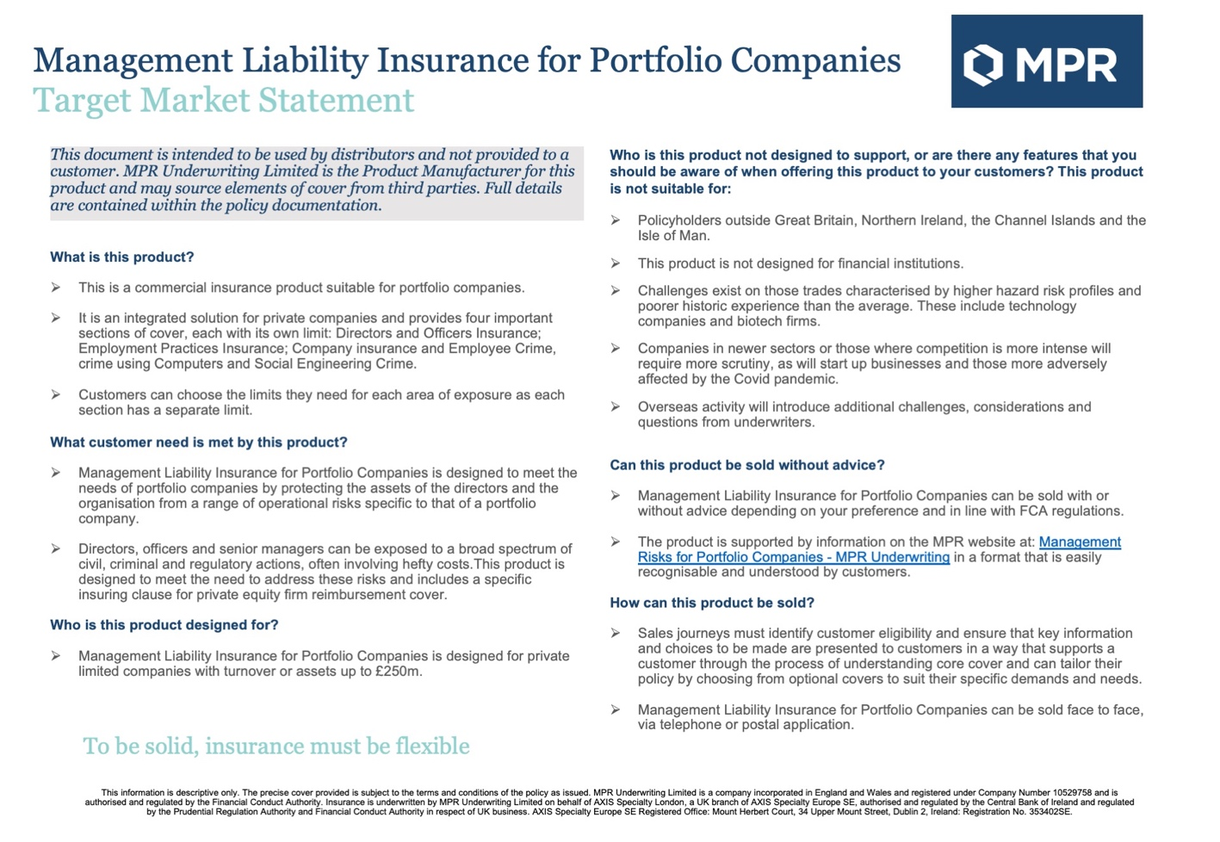

Broker Information
The fields below should be completed for all distributors in the chain. Distributor 1 should be the distributor in direct contact with the carrier and the highest distributor number should be the distributor in direct contact with the customer. The information provided should include the type and amount of remuneration (including fees and commissions) of each distributor, where this is part of the premium or otherwise paid by the customer, for the product. See page 1 for further guidance.

Distributor 1 – [insert name]
Total commissions
Total fees
Other
Explanation of services provided
Information on any ancillary products/services sold alongside the product which may affect the product’s value.
It is confirmed that the above remuneration paid by the customer is consistent with the regulatory obligations of Distributor 1. |  | Yes | No
For this product, we are a wholesale or placing broker for other brokers/intermediaries. |  | Yes | No

Distributor 2– [insert name]
Total commissions
Total fees
Other
Explanation of services provided
Information on any ancillary products/services sold alongside the product which may affect the product’s value.
It is confirmed that the above remuneration paid by the customer is consistent with the regulatory obligations of Distributor 2. |  | Yes | No
For this product, we are a wholesale or placing broker for other brokers/intermediaries. |  | Yes | No

Distributor 3– [insert name]
Total commissions
Total fees
Other
Explanation of services provided
Information on any ancillary products/services sold alongside the product which may affect the product’s value.
It is confirmed that the above remuneration paid by the customer is consistent with the regulatory obligations of Distributor 3. |  | Yes | No
For this product, we are a wholesale or placing broker for other brokers/intermediaries. |  | Yes | No

Distributor 4– [insert name]
Total commissions
Total fees
Other
Explanation of services provided
Information on any ancillary products/services sold alongside the product which may affect the product’s value.
It is confirmed that the above remuneration paid by the customer is consistent with the regulatory obligations of Distributor 4. |  | Yes | No
For this product, we are a wholesale or placing broker for other brokers/intermediaries. |  | Yes | No

Distributor 5– [insert name]
Total commissions
Total fees
Other
Explanation of services provided
Information on any ancillary products/services sold alongside the product which may affect the product’s value.
It is confirmed that the above remuneration paid by the customer is consistent with the regulatory obligations of Distributor 5. |  | Yes | No
For this product, we are a wholesale or placing broker for other brokers/intermediaries. |  | Yes | No

